WEEK 1 INTERNSHIP REPORT | MEDICAL DEVICE CONCEPT DESIGN

MEDICAL DEVICE CONCEPT DESIGN AND SPECIFICATION
Smart Diabetic Foot Monitoring Insole

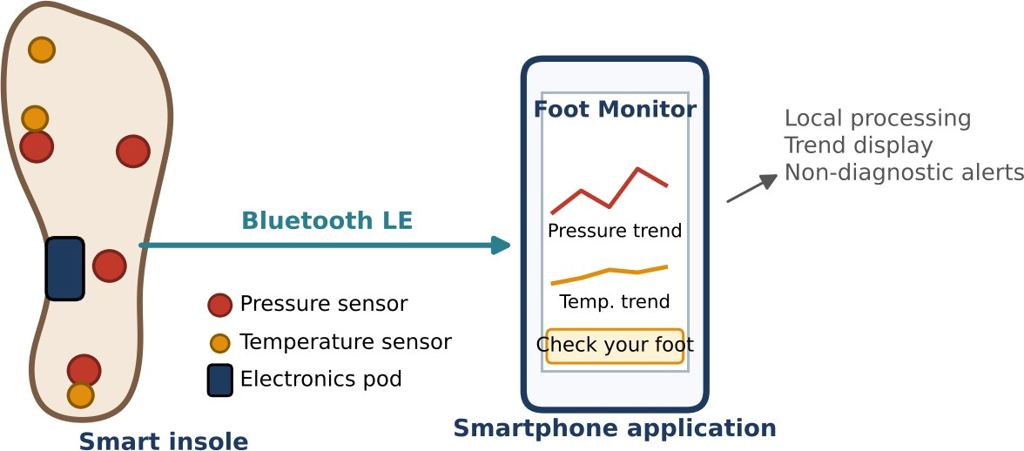

Figure 1. Concept overview: sensorized insole with removable electronics pod communicating with a smartphone application via BLE.

Submitted by Nishadevi M

Programme Biomedical Engineering
Institution Sri Ramakrishna Engineering College

Internship YuvaIntern – Online Internship
Task Week 1 – Medical Device Concept Design and Specification

Submission type Conceptual engineering design report

TABLE OF CONTENTS

DECLARATION AND DESIGN STATUS 3
EXECUTIVE SUMMARY 3
- INTRODUCTION AND HEALTHCARE NEED 3
  - Need for the proposed device 3
  - Intended users and use environment 4
- PROBLEM DEFINITION AND DESIGN OBJECTIVES 4
  - Problem statement 4
  - Design objectives 4
  - Design constraints and assumptions 4
- EXISTING SOLUTIONS AND UNMET NEEDS 4
  - Unmet needs addressed by this concept 5
- PROPOSED CONCEPT AND DESIGN RATIONALE 5
  - Major subsystems 6
  - Conceptual sensor placement 7
  - Design rationale 7
- SYSTEM ARCHITECTURE AND WORKING PRINCIPLE 8
  - Working sequence 8
  - Signal processing concept 8
  - Data flow and privacy 9
- DETAILED DESIGN SPECIFICATIONS 9
  - Materials 10
  - Electronics and circuit considerations 10
  - Firmware and mobile software 10
  - Supporting engineering calculations 10
- FUNCTIONAL AND NON-FUNCTIONAL REQUIREMENTS 12
- USER WORKFLOW AND INTERFACE CONCEPT 12
  - Daily use 12
  - Alert language 13
- SAFETY, RISK MANAGEMENT AND USABILITY 13
  - Safety mechanisms 15
  - Usability and cleaning 15
- VERIFICATION AND VALIDATION PLAN 15
  - Calibration approach 16
  - Prototype development stages 16
- STANDARDS AND REGULATORY CONSIDERATIONS 16
  - Regulatory pathway 17
- ANTICIPATED BENEFITS, LIMITATIONS AND FUTURE WORK 17
  - Anticipated benefits 17
  - Limitations 17
  - Future development 18
- CONCLUSION 18
- REFERENCES 18
APPENDIX A – PRELIMINARY BILL OF MATERIALS 20
APPENDIX B – PRELIMINARY DESIGN REVIEW CHECKLIST 20
APPENDIX C – GLOSSARY 20

DECLARATION AND DESIGN STATUS
This report presents an original conceptual biomedical device design prepared for an academic internship task. The proposed Smart Diabetic Foot Monitoring Insole is a design concept and has not been manufactured, clinically validated, or approved for medical use.
All numerical performance values in this report are proposed engineering targets for a future prototype, or are stated design assumptions and worked estimates, unless explicitly identified otherwise. They are not measured results. The device is intended to support awareness and monitoring; it must not be used to diagnose diabetic foot ulcers, replace professional foot examinations, or determine treatment.

EXECUTIVE SUMMARY
Diabetes-related peripheral neuropathy and vascular complications can reduce protective sensation and increase the likelihood that minor foot injuries remain unnoticed. Repeated high plantar loading and local temperature changes may be warning signs that deserve attention. This report proposes a wearable insole that combines plantar-pressure sensors and temperature sensors, a low-power microcontroller, Bluetooth Low Energy (BLE), and a mobile application.
The insole collects data during normal wear, processes signals locally, compares readings with an individual’s baseline and configurable alert rules, and displays trends or warnings to the user. The design emphasises comfort, low profile, electrical safety, cleanability, battery protection, data privacy, and clear communication that alerts are not diagnoses.
The report covers the clinical need, existing solution categories, the proposed concept and architecture, detailed component and material specifications, supporting engineering calculations, functional requirements, a scored risk analysis, a verification and validation plan, the applicable standards landscape, limitations, and future development.

INTRODUCTION AND HEALTHCARE NEED
Diabetes mellitus is a long-term metabolic condition that can lead to complications affecting nerves and blood vessels. The International Diabetes Federation estimated that about 537 million adults aged 20–79 were living with diabetes in 2021 [1]. In the feet, loss of protective sensation can make it difficult for a person to notice excessive pressure, friction, blisters, cuts, or early tissue damage. The lifetime risk of a foot ulcer in people with diabetes has been estimated at 19–34% [13], and ulcers can progress to infection and amputation if warning signs are not identified and acted upon promptly. Regular foot inspection, appropriate footwear, clinical assessment, and education remain essential elements of prevention [2].
A wearable monitoring device may add information between scheduled clinical visits. Plantar pressure monitoring can show where load is concentrated during standing or walking. Temperature monitoring can identify local changes that may warrant closer inspection. Neither signal alone proves that an ulcer is present. Measurements can also be influenced by walking speed, footwear fit, ambient temperature, sensor drift, moisture, and individual differences.

Need for the proposed device
The proposed insole aims to provide a practical way to observe pressure distribution and local temperature trends while the user wears ordinary footwear. It is designed as a monitoring aid that can prompt the user to inspect the foot and seek clinical advice when persistent or unusual patterns appear.

Intended users and use environment
    - Primary intended users: adults with diabetes who have been advised by a healthcare professional to monitor foot loading or temperature.
    - Secondary users: caregivers and clinicians reviewing trends, where the user has consented to share data.
    - Use environment: indoor and outdoor daily activities in compatible footwear; not intended for immersion, bathing, or use outside the specified operating range.
    - Not intended for: diagnosis, emergency triage, autonomous treatment decisions, or use as a substitute for prescribed therapeutic footwear or clinical review.

PROBLEM DEFINITION AND DESIGN OBJECTIVES

Problem statement
People with diabetes-related loss of protective sensation may not recognise harmful pressure or early skin changes in the foot. Periodic visual checks can be difficult to perform consistently, and a user may not notice a developing problem during daily activity. A compact, comfortable monitoring insole could provide additional trend information and reminders to inspect the foot.

Design objectives
    - Measure plantar pressure at selected load-bearing regions during standing and walking.
    - Measure local temperature at selected plantar regions and track changes over time.
    - Process sensor data using a low-power embedded controller.
    - Transmit summarised readings and alerts to a smartphone using BLE.
    - Provide clear, understandable alerts with advice to inspect the foot and contact a clinician when appropriate.
    - Protect the user through electrical, mechanical, thermal, material, battery, and software safeguards.
    - Keep the device thin, flexible, cleanable, serviceable, and compatible with selected footwear.

Design constraints and assumptions
The first prototype is assumed to be a single-foot or paired-foot insole with a small number of sensing zones. A small sensor array is preferred over a dense array to reduce cost, wiring complexity, power consumption, and thickness. The user is expected to charge the device and pair it with a compatible smartphone. Clinical thresholds must be determined through research and validation; the prototype must not present arbitrary thresholds as universal clinical cut-offs.

EXISTING SOLUTIONS AND UNMET NEEDS
Existing approaches include routine clinician foot examinations, visual self-inspection, pressure-relieving therapeutic footwear, pressure measurement systems used in gait laboratories or clinics, and commercially available sensorised products. Some systems emphasise plantar pressure mapping, while others measure temperature, activity, or enable remote data review. Availability, feature sets, accuracy, regulatory status, and clinical evidence vary by product and market.

Table 1. Comparison of existing solution categories and the proposed concept.

Solution category | Typical capability | Potential limitation / design opportunity
Clinical foot examination | Visual inspection, sensory testing, vascular assessment and professional advice. | Periodic rather than continuous; depends on access and attendance.
Therapeutic footwear / offloading | Redistributes load and reduces pressure at selected areas [3]. | Does not necessarily provide electronic monitoring or trend alerts.
Clinic-based pressure measurement | Maps plantar loading during a controlled assessment. | May be expensive, location-bound, and not continuously worn.
Sensorised insoles (e.g. pressure-sensing insoles with alerts) | Measure pressure, gait or activity and send data wirelessly. | Cost, fit, battery life, data interpretation, maintenance and accessibility vary.
Home temperature monitoring (e.g. temperature mats, smart socks) | Detect local temperature differences between feet at home. | Usually measure temperature only, and may not capture loading during walking.
Proposed concept | Low-profile pressure and temperature trend monitoring with BLE and user alerts. | Requires prototype testing, individual calibration, usability work and clinical validation.
The proposed design does not claim that no comparable product exists. Product examples above are categories given for illustration, and their current features and regulatory status should be checked before any comparison is made. Its intended contribution is a clearly specified, modular, educational prototype concept that emphasises low-cost component selection, transparent alert logic, local processing, user safety, and a documented verification plan. A formal market review and freedom-to-operate assessment would be needed before commercialisation.

Unmet needs addressed by this concept
    - A simple daily-use interface that presents trends rather than overwhelming raw sensor values.
    - A combination of pressure and temperature observations in one wearable platform.
    - Explicit battery, sensor-fault, BLE-disconnection, and data-quality warnings.
    - A design specification that makes calibration, cleaning, fit, and risk controls part of the device concept.

PROPOSED CONCEPT AND DESIGN RATIONALE
The Smart Diabetic Foot Monitoring Insole is a thin, flexible insert containing discrete pressure-sensing elements at selected plantar regions and temperature sensors near selected contact zones. A small electronics module is positioned at the medial arch, where it is less exposed to direct loading. Flexible interconnects route sensor signals to the module. The module samples, filters, and summarises data before sending it to a phone.

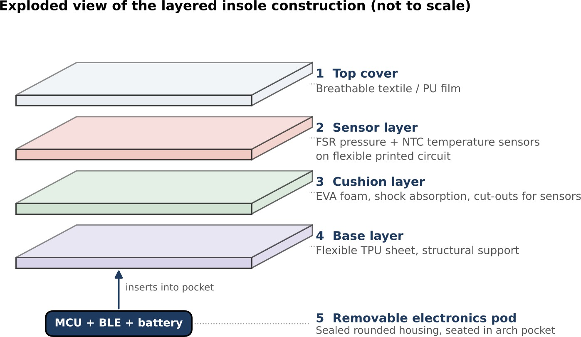

Figure 2. Concept sketch: exploded view of the layered insole and removable electronics pod.

Major subsystems
Table 2. Major subsystems, proposed implementation and rationale.

Subsystem | Proposed implementation | Design rationale
Mechanical insole | Layered flexible insole with removable electronics module. | Comfort, replaceability and easier cleaning.
Pressure sensing | Thin-film force-sensitive resistors (FSRs) or piezoresistive elements. | Compact, low-cost detection of relative load changes.
Temperature sensing | Small NTC thermistors or digital temperature sensors. | Low power and suitable for local temperature trend measurement.
Controller | Low-power microcontroller with ADC and BLE capability. | Sensor acquisition, processing and wireless communication.
Power | Protected rechargeable lithium-polymer cell in enclosed module. | Portable operation with charging and fault protection.
Mobile application | Pairing, live status, trends, alerts and educational instructions. | Makes readings understandable and actionable.

Conceptual sensor placement
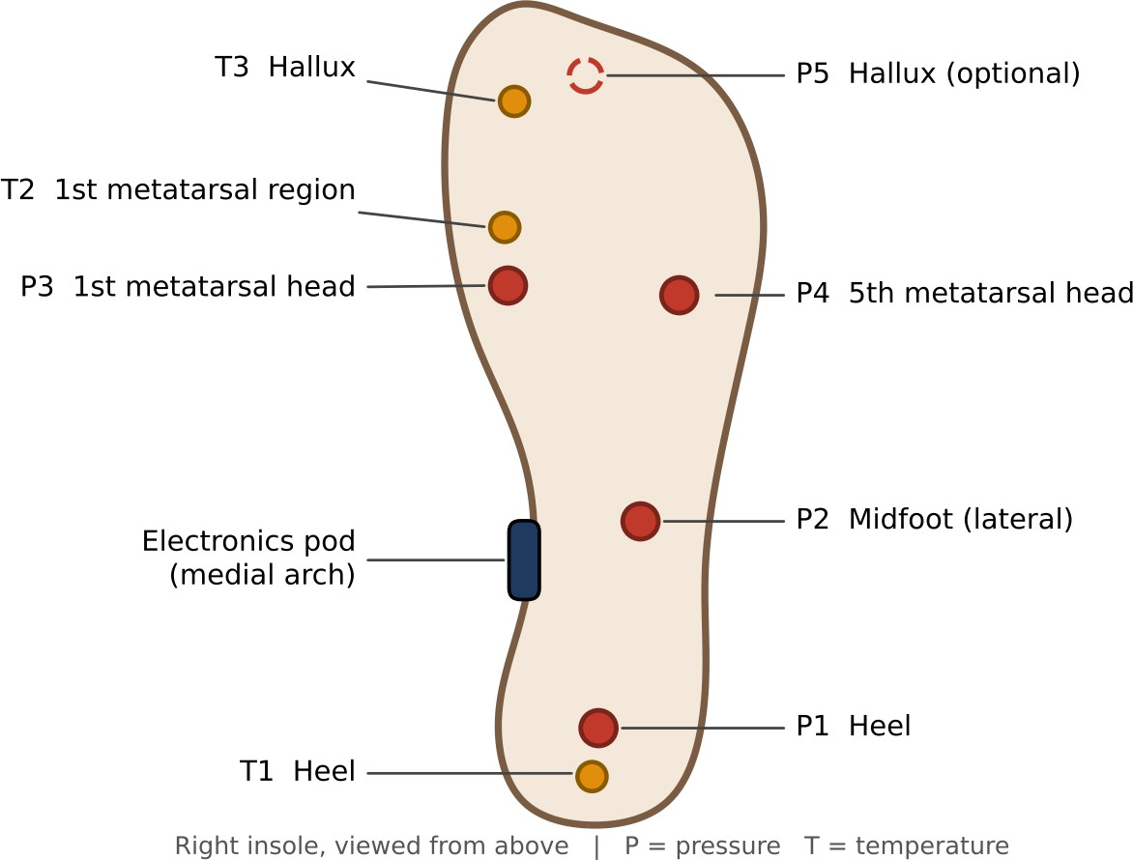
Figure 3. Illustrative plantar sensor locations (right insole). Final placement must be adapted to foot anatomy and validated fit.
Pressure sensors are proposed at the heel, midfoot and metatarsal-head regions, with an optional hallux sensor. Temperature sensors are proposed near selected high-risk plantar regions. The metatarsal heads, hallux and heel are commonly loaded regions in the diabetic foot, which is why they are prioritised. The exact count and location must be finalised after anatomical review, gait testing, and evaluation of sensor comfort. The figure is conceptual and is not a clinical placement prescription.

Design rationale
A hybrid pressure–temperature design offers complementary information: pressure indicates mechanical loading, while temperature indicates local thermal change. A baseline-based approach can account for some between-person differences, but it cannot eliminate confounding factors. Local processing reduces dependence on continuous internet access and allows the insole to flag sensor faults before sending summaries. BLE is selected because the data volume is modest and a smartphone can provide the display and notification functions.

SYSTEM ARCHITECTURE AND WORKING PRINCIPLE

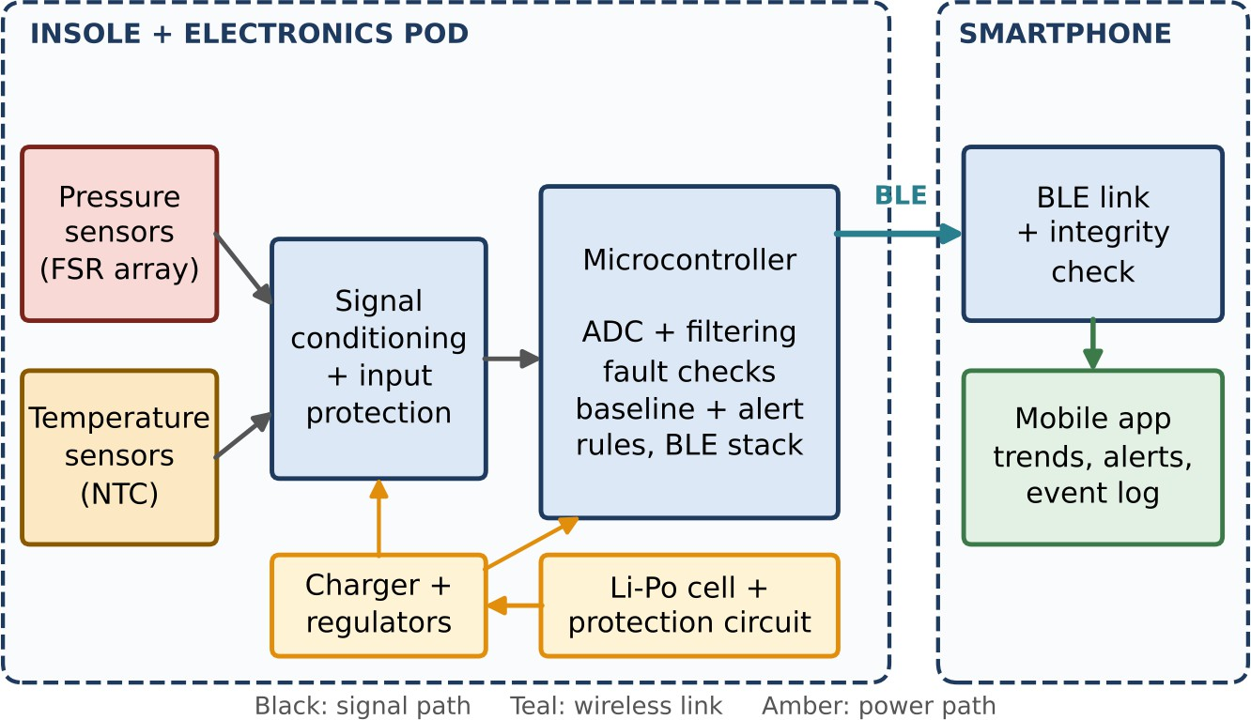

Figure 4. Functional block diagram of the proposed device showing signal, wireless and power paths.

Working sequence
- The user places the insole in compatible footwear and checks that it lies flat without folds or sharp edges.
- Pressure sensors respond to applied plantar load by changing their electrical resistance or output voltage, depending on sensor type.
- Temperature sensors measure local temperature at selected contact zones.
- The microcontroller samples signals through its analogue-to-digital converter (ADC) or digital sensor interface.
- Firmware filters noise, checks sensor plausibility, identifies missing or saturated channels, and calculates summary features.
- The controller compares current readings with stored personal baseline values and configurable engineering alert rules.
- Summaries and alert states are transmitted to the paired smartphone using BLE.
- The application displays trends, device status, and cautious guidance to inspect the foot or contact a healthcare professional.

Signal processing concept
For each pressure channel, the firmware may calculate a moving average or median over a short window to reduce transient noise. A normalised pressure index can be calculated relative to a calibrated reference for that sensor. Temperature data can be filtered and compared with a personal baseline collected under consistent conditions. The system should consider persistence over time rather than triggering on a single sample.
Illustrative engineering logic (not a clinical diagnostic rule): flag a review condition when a sensor remains outside its personalised expected range for a defined persistence interval, or when a temperature difference between

corresponding foot regions is sustained. Exact thresholds and intervals must be set only after literature review, clinician input, bench testing, and clinical validation. The user interface must say “check your foot / seek advice” rather than “ulcer detected.”

Data flow and privacy
The initial prototype should store only the minimum information needed for trend review: timestamp, sensor summaries, device status, and user-selected baseline. Data transmission should be encrypted where supported by the chosen BLE/application stack. Pairing should require user action. The application should explain what data are stored, where they are stored, how long they are retained, and how a user can delete or export them. No cloud upload is necessary for the first prototype.

DETAILED DESIGN SPECIFICATIONS
The following values are preliminary design targets for a proof-of-concept prototype. They must be refined after component selection, bench characterisation, and user testing.
Table 3. Preliminary design specification.

Parameter | Proposed target / specification | Notes
Sensing zones | 4–6 pressure zones per insole; 2–4 temperature points | Prototype range; final number depends on comfort and cost.
Pressure sensor type | Thin-film FSR / piezoresistive sensor | Requires individual calibration; output may be nonlinear and exhibit hysteresis.
Pressure measurement | Relative plantar-load trend; calibrated range selected after bench tests | Do not claim clinical pressure accuracy before validation.
Temperature sensor | NTC thermistor or digital temperature IC | Select encapsulated,  skin-contact-compatible construction.
Temperature resolution | Target 0.1 °C display increment; accuracy to be established by calibration | Display resolution is not the same as accuracy.
Sampling | 1–10 samples/s per channel, configurable | Higher rates increase power and data volume.
Controller | Low-power MCU with ADC and BLE | Example platform: ESP32-C3 or equivalent; final choice depends on power and RF testing.
Wireless link | Bluetooth Low Energy | Phone compatibility and reconnection behaviour must be tested.
Power source | Protected rechargeable Li-ion / Li-poly cell | Battery size determined by measured current consumption and desired runtime.
Operating time | At least one full day (24 h) of intermittent monitoring | Must be verified under realistic sampling and transmission duty cycle.
Enclosure | Rounded, sealed electronics pod positioned away from high-load zones | Must resist sweat ingress and mechanical impact.
Insole thickness | Under 5 mm in sensing areas, excluding removable pod | Comfort and footwear fit must be evaluated.
Operating environment | Provisional 10–40 °C ambient range | Final limits depend on component ratings and validation.
App platform | Android first; iOS considered in later development | App displays trends, warnings, battery and connectivity state.

Materials
Table 4. Candidate materials and selection considerations.

Part | Candidate material | Selection considerations
Top cover | Breathable textile or medical-grade polyurethane film | Skin comfort, moisture management, abrasion resistance and cleanability.
Cushion layer | EVA foam or comparable compliant polymer | Shock absorption, resilience, low mass and low moisture retention.
Base layer | Flexible TPU or suitable polymer sheet | Flexibility, durability and sensor support.
Sensor encapsulation | Thin polyurethane / silicone encapsulant | Electrical insulation, sweat resistance and biocompatibility assessment.
Conductors | Flexible printed circuit or insulated fine-strand wires | Repeated bending, strain relief and fatigue life.
Electronics enclosure | Rounded polymer housing | Impact protection, secure closure and cleanability.
Material selection is provisional. Any material that contacts the user directly or indirectly must be evaluated for the intended contact type and duration. Supplier declarations alone do not replace a biological evaluation of the finished device [9].

Electronics and circuit considerations
    - Use regulated supply rails for sensors and controller; include reverse-polarity and overcurrent protection where appropriate.
    - Add analogue filtering and appropriate ADC input protection to reduce noise and prevent input overvoltage.
    - Use strain-relieved flexible connections and avoid placing rigid components under the heel or metatarsal heads.
    - Include a battery protection circuit for overcharge, over-discharge, overcurrent and short-circuit conditions.
    - Provide a clear charging indicator and disable measurement or wireless transmission if an unsafe battery condition is detected.

Firmware and mobile software
    - Sensor sampling, calibration coefficients, filtering and plausibility checks.
    - Detection of open-circuit, short-circuit, stuck, saturated or implausible sensor readings.
    - Baseline setup and user instructions for consistent measurement conditions.
    - BLE pairing, reconnection, packet integrity checks and low-battery reporting.
    - Alert persistence, acknowledgement, event log and clear non-diagnostic language.
    - Software version identification, update controls and basic cybersecurity protections.

Supporting engineering calculations
The following worked estimates demonstrate the engineering principles behind the specification. They use assumed typical component values and must be replaced by measured values once components are selected.

- Pressure channel conditioning. Each FSR is placed in a voltage divider with a fixed resistor R
m
(for

example 10 kfi) from a regulated Vcc = 3.3 V supply. The measured voltage is

As load increases, R
FSR

falls and V
V = V · R / (R + R )
out cc m m FSR
out rises, giving a monotonic but nonlinear response that is linearised

through per-sensor calibration (Section 10.1). A unity-gain buffer and a low-pass filter (cut-off of a few hertz, well above the gait stride frequency) limit noise and aliasing.
- Temperature channel. A 10 kfi NTC thermistor with a typical B constant of 3950 K follows R =
R ·exp[B(1/T − 1/T )], with T in kelvin and T = 298.15 K. At a skin-contact temperature of about 33 °C
0 0 0
(306.15 K), R ≈ 7.07 kfi and the slope is dR/dT = −B·R/TZ ≈ −0.30 kfi/°C. In a divider with a 10 kfi fixed resistor on a 3.3 V rail, this corresponds to a sensitivity of roughly 34 mV/°C.
- ADC resolution. A 12-bit ADC with a 3.3 V reference has a least significant bit of 3.3 / 4096 ≈ 0.81 mV. For the thermistor divider above, one LSB corresponds to about 0.02 °C in theory. This supports a 0.1
°C display increment, but real accuracy will be limited by thermistor tolerance, self-heating, reference stability and noise, and is established only by calibration.
- Power budget and battery sizing. The estimated average current drawn from the cell is summarised below. Values are design assumptions for a duty-cycled system (MCU asleep between samples, BLE connection interval of about one second).
Table 5. Estimated average current budget (design assumptions).

Load | Assumed average current (mA) | Basis
MCU (active at low duty cycle, sleep otherwise) | 0.80 | Wake for sampling and processing only.
BLE radio (connected, low-rate summaries) | 0.45 | Long connection interval; small packets.
Pressure dividers (powered only during sampling) | 0.10 | Gated supply reduces idle current.
Temperature dividers | 0.05 | Pulsed during measurement.
Regulator, protection and quiescent losses | 0.03 | Low-quiescent components.
Total | 1.43
For a 150 mAh Li-polymer cell with 80% usable capacity (120 mAh), the theoretical runtime is 120 / 1.43
≈ 84 h. Allowing a 50% derating for temperature, ageing, retransmissions and unmodelled loads gives about 40 h, which meets the 24 h target with margin. This remains an estimate until verified by measurement (Section 10).

FUNCTIONAL AND NON-FUNCTIONAL REQUIREMENTS
Table 6. Requirements and acceptance evidence.

ID | Requirement | Acceptance evidence
FR-01 | The insole shall acquire readings from each installed pressure sensor. | Bench test confirms every channel reports data.
FR-02 | The insole shall acquire readings from each temperature sensor. | Comparison against calibrated reference thermometer.
FR-03 | The system shall identify disconnected or implausible sensor channels. | Fault-injection test produces a sensor-fault status.
FR-04 | The controller shall filter and summarise readings. | Recorded test signals match documented algorithm outputs.
FR-05 | The device shall transmit data to a paired phone using BLE. | Connection, packet and range tests.
FR-06 | The app shall display sensor status, trends, battery and connection state. | Usability test with representative users.
FR-07 | The app shall issue a caution alert for configured persistent abnormal patterns. | Software test vectors verify alert logic.
FR-08 | The app shall not label an alert as a diagnosis. | Content and usability review.
FR-09 | The app shall allow the user to view, export and delete stored data. | Functional test and privacy review.
NFR-01 | The insole shall not create painful pressure points or sharp edges. | Fit, inspection and supervised wear evaluation.
NFR-02 | The electronics shall be protected from expected sweat exposure. | Ingress and cleaning tests appropriate to design.
NFR-03 | The battery shall have protective circuitry. | Electrical and battery safety verification.
NFR-04 | The device shall preserve data integrity during BLE interruptions. | Disconnect/reconnect and packet-loss testing.
NFR-05 | The device shall provide understandable instructions and alerts. | Usability engineering evaluation.
NFR-06 | The device shall operate for at least 24 h per charge under the defined duty cycle. | Battery runtime test with safety margin.

USER WORKFLOW AND INTERFACE CONCEPT
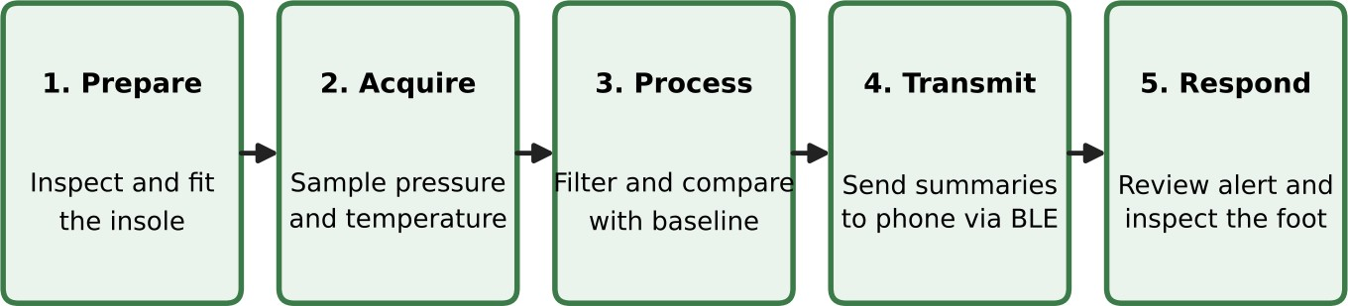

Figure 5. Proposed user workflow from fitting the insole to responding to an alert.

Daily use
    - Inspect the insole and electronics pod for damage before use.

    - Place the insole correctly in compatible footwear; ensure it is flat and does not alter shoe fit excessively.
    - Open the application and confirm battery, sensor and Bluetooth status.
    - Wear the footwear as instructed; remove the device if discomfort, heat, skin irritation or pressure occurs.
    - Review trend summaries and any caution messages. Follow the clinician’s advice for foot inspection and care.
    - Charge the device using the specified charger and keep the electronics module dry during charging.

Alert language
Recommended message: “A persistent change has been observed in your foot-monitoring readings. Remove your footwear and inspect your feet. If you notice redness, swelling, a blister, a wound, warmth, pain, discharge, or any concern, contact your healthcare professional promptly. This device does not diagnose a foot condition.”
The app should distinguish sensor fault, low battery, disconnected phone, and a monitoring caution. It should not use alarming colours or wording for uncertain measurements, and it should not instruct a user to ignore symptoms because the readings appear normal.

SAFETY, RISK MANAGEMENT AND USABILITY
Risk management should be performed throughout the device lifecycle in line with ISO 14971 [4]. The preliminary hazard analysis below identifies foreseeable hazards and example controls. Ratings are qualitative and provisional; a formal risk-management file must define severity and probability scales, acceptance criteria, verification evidence, and residual-risk approval.

Table 7. Preliminary hazard analysis.

ID | Hazard / hazardous situation | Possible cause | Potential harm | Proposed risk controls
H1 | False negative: concerning condition not flagged | Sensor drift, poor placement, insufficient sampling, unsuitable threshold | Delayed foot inspection or clinical assessment | Calibration, sensor diagnostics, conservative wording, routine foot-care reminders, validation across users.  Cannot be eliminated; device never replaces clinical care.
H2 | False positive alert | Transient pressure spike, ambient temperature change, noise | Anxiety, unnecessary checks or care-seeking | Persistence logic, baseline comparison, clear uncertainty language, alert acknowledgement.
H3 | Pressure point or discomfort | Rigid component, wrinkled insole, poor shoe fit | Skin irritation, blister or tissue injury | Thin flexible layers, pod outside load zones, fit testing, stop-use instruction.
H4 | Skin irritation / material reaction | Unsuitable adhesive, coating or textile | Dermatitis or irritation | Material screening, biological evaluation, contact-duration assessment, cleanable surfaces.
H5 | Electrical fault / short circuit | Sweat ingress, damaged insulation, assembly defect | Heating, shock or device failure | Low-voltage design, insulation, current limiting, sealed enclosure, inspection tests.
H6 | Battery overheating or failure | Cell damage, incorrect charger, protection failure | Burn, fire or property damage | Certified cell, protection circuit, controlled charger, temperature monitoring, enclosure and charging instructions.
H7 | Data loss or incorrect display | BLE dropouts, corrupted packets, software defect | User misunderstands monitoring status | Packet checks, timestamps, stale-data warning, fault state, software verification.
H8 | Cybersecurity / privacy breach | Weak pairing, insecure storage or transmission | Disclosure or alteration of personal data | Authenticated pairing, encryption, minimal data, access controls, secure updates.
H9 | Trip or gait disturbance | Insole thickness, poor fit, cable or pod snag | Fall or musculoskeletal injury | Low-profile design, no exposed cables, footwear compatibility and gait evaluation.
H10 | Cleaning-related damage | Liquid enters electronics or harsh chemicals used | Failure, skin exposure or inaccurate readings | Removable sealed pod, validated cleaning instructions, inspection before reuse.
Risk scoring. Severity (S) is rated 1 (negligible) to 5 (catastrophic) and probability (P) from 1 (remote) to 5 (frequent). Risk = S × P is classified as Low (1–4, acceptable), Medium (5–9, reduce as far as reasonably practicable) or High (10–25, unacceptable without further control). All scores below are provisional team estimates for illustration and must be confirmed in a formal risk-management file.

Table 8. Provisional risk scoring before and after risk controls.

ID | Initial S | Initial P | Initial risk | Residual S | Residual P | Residual risk | Residual level
H1 | 4 | 4 | 16 (High) | 4 | 2 | 8 | Medium
H2 | 2 | 4 | 8 (Medium) | 2 | 3 | 6 | Medium
H3 | 3 | 3 | 9 (Medium) | 3 | 2 | 6 | Medium
H4 | 2 | 3 | 6 (Medium) | 2 | 1 | 2 | Low
H5 | 4 | 2 | 8 (Medium) | 4 | 1 | 4 | Low
H6 | 5 | 2 | 10 (High) | 5 | 1 | 5 | Medium
H7 | 3 | 3 | 9 (Medium) | 3 | 2 | 6 | Medium
H8 | 3 | 3 | 9 (Medium) | 3 | 2 | 6 | Medium
H9 | 4 | 2 | 8 (Medium) | 4 | 1 | 4 | Low
H10 | 2 | 3 | 6 (Medium) | 2 | 1 | 2 | Low
Residual risks that remain Medium (notably H1 false negatives, H3 pressure points, H7 data display and H8 security) require formal benefit–risk review, clear instructions for use, and post-market surveillance in any future clinical product. Battery safety (H6) remains one of the most severe hazards and demands certified cells and dedicated testing even though its residual probability is low.

Safety mechanisms
    - Mechanical: rounded edges, flexible sensor layers, strain relief, secure pod attachment and no exposed conductors.
    - Electrical: extra-low-voltage operation, insulation, current limiting, battery protection and controlled charging.
    - Thermal: component temperature limits and automatic shutdown if abnormal internal temperature is detected.
    - Software: sensor plausibility checks, watchdog, stale-data indication, safe default state and clear fault messages.
    - Human factors: plain-language instructions, accessible alert display, no diagnosis claims and stop-use guidance for discomfort.

Usability and cleaning
The device should be evaluated with intended users and caregivers for donning, doffing, fit, charging, pairing, alert comprehension, and cleaning, following usability engineering practice [8]. The removable electronics pod should be detached before cleaning if the design requires it. Cleaning agents, wiping method, drying time, and reuse limits must be specified only after material compatibility tests.

VERIFICATION AND VALIDATION PLAN
Verification asks whether the design meets its engineering specifications. Validation asks whether the finished device meets user needs in the intended use environment. The activities below are proposed; no tests are claimed to have been completed.

Table 9. Proposed verification and validation activities.

Test area | Proposed method | Example pass criterion / evidence
Pressure channel calibration | Apply known loads using a calibrated force gauge or test rig at each sensing zone. | Monotonic response and repeatability within a pre-defined engineering tolerance.
Temperature accuracy | Compare each sensor against a traceable reference over the intended operating range. | Error remains within the tolerance specified after component selection.
Drift and hysteresis | Repeated load/unload cycles and long-duration fixed-load tests. | Drift and hysteresis characterised and acceptable for trend monitoring.
Bending / fatigue | Repeated flexing representative of walking and shoe insertion. | No conductor break, delamination or unsafe sharp edge.
BLE communication | Test pairing, range, packet loss, reconnection and phone compatibility. | No silent data gaps; stale data clearly indicated.
Battery runtime | Run representative sampling and BLE duty cycle until low-battery cutoff. | Meets the finalised runtime target with safety margin.
Ingress / sweat resistance | Expose assembled unit to defined artificial sweat and cleaning conditions. | No ingress-related failure or unsafe behaviour.
Usability | Formative testing with representative users and clinicians. | Users can fit, pair, interpret status and respond to alerts.
Software verification | Unit, integration, boundary, fault-injection and regression tests. | Requirements traceable to test cases; no unresolved critical defects.
Clinical validation | Ethics-approved study comparing device outputs with accepted clinical assessment methods. | Study protocol and statistical plan approved before enrolment; no claims before results.

Calibration approach
Each pressure sensor should be characterised individually because thin-film sensors may be nonlinear and exhibit hysteresis. A calibration curve can map ADC counts to a relative or estimated force range under controlled conditions. Temperature sensors should be calibrated against a reference thermometer. Calibration coefficients and dates should be stored with the device. Recalibration intervals must be determined from drift testing.

Prototype development stages
    - Stage 1 – Breadboard proof of concept: test sensors, ADC acquisition, BLE and basic app display.
    - Stage 2 – Flexible insole prototype: integrate sensors and flexible wiring; evaluate comfort and mechanical durability.
    - Stage 3 – Engineering verification: calibration, drift, battery, ingress, electrical and software tests.
    - Stage 4 – Usability evaluation: assess fit, instructions, alert comprehension and cleaning.
    - Stage 5 – Clinical research: obtain ethics approval, define endpoints, recruit appropriate participants and evaluate performance against clinical reference methods.
    - Stage 6 – Regulatory preparation: finalise quality, risk, usability, software and clinical documentation according to target market requirements.

STANDARDS AND REGULATORY CONSIDERATIONS
The standards listed below are relevant reference frameworks, but applicability depends on the final intended purpose, claims, architecture, electrical classification, software role, and target market. The latest adopted editions and national requirements must be checked before design freeze or commercialisation.

Table 10. Relevant standards and frameworks.

Standard / framework | Relevance to this concept
ISO 14971 – Application of risk management to medical devices [4] | Risk-management process across design, manufacture and post-market stages.
IEC 60601-1 – Medical electrical equipment: basic safety and essential performance [5] | Potentially relevant if the finished product is classified as medical electrical equipment; applicability must be assessed.
IEC 60601-1-2 – Electromagnetic disturbances [6] | EMC emissions and immunity considerations for electronic medical equipment, where applicable.
IEC 62304 – Medical device software lifecycle processes [7] | Software development, maintenance, risk classification and verification practices.
IEC 62366-1 – Usability engineering for medical devices [8] | Usability engineering to reduce use-related risks.
ISO 10993-1 – Biological evaluation of medical devices [9] | Biological evaluation planning for materials with direct or indirect body contact.
ISO 13485 – Quality management systems [10] | Quality-management framework for organisations developing or manufacturing medical devices.
ISO 15223-1 and ISO 20417 | Symbols and information supplied by the manufacturer, where applicable.
IEC 62133-2 and relevant battery transport requirements [12] | Safety considerations for portable sealed lithium cells and batteries; confirm applicability to the selected cell and product.

Regulatory pathway
In India, classification and licensing requirements should be determined under the Medical Devices Rules, 2017 and current Central Drugs Standard Control Organisation (CDSCO) guidance [11]. The intended purpose and claims influence whether the product is regulated as a medical device and its risk class. A prototype used for research or demonstration must not be represented as approved for patient care. Before any human study, institutional ethics review, informed consent, data protection, and appropriate clinical investigation requirements must be addressed.
For other markets, separate assessment is required (for example, the applicable US FDA or EU Medical Device Regulation pathway). A standards list is not evidence of compliance. Compliance requires documented applicability decisions, testing, quality processes, and regulatory review.

ANTICIPATED BENEFITS, LIMITATIONS AND FUTURE WORK

Anticipated benefits
    - Provides additional information on plantar loading and local temperature trends during daily wear.
    - May prompt earlier self-inspection or professional consultation when persistent changes occur.
    - Combines sensing, embedded processing and mobile communication in a wearable biomedical platform.
    - Modular construction may allow replacement or servicing of the electronics module.
    - The design can support future research into personalised monitoring and risk communication.

Limitations
    - Pressure sensors may be nonlinear, show hysteresis and drift, and require frequent calibration.

    - Temperature readings are influenced by ambient conditions, socks, footwear, activity and sensor contact.
    - A small number of sensors cannot map the entire plantar surface and may miss localised changes.
    - Alert thresholds are not established by this conceptual design and must not be assumed clinically valid.
    - Battery life, comfort, cleaning durability, BLE reliability and cost are unverified until prototype testing.
    - The device cannot diagnose infection, ischaemia, neuropathy or ulceration and cannot replace routine foot care.

Future development
    - Develop a flexible printed sensor array with improved spatial resolution and reduced wiring.
    - Evaluate pressure-sensor alternatives and compensation methods for temperature, hysteresis and drift.
    - Develop paired-foot comparison features, while avoiding simplistic assumptions that both feet should be identical.
    - Conduct co-design with podiatrists, diabetologists, rehabilitation specialists and people living with diabetes.
    - Improve app accessibility, multilingual support, offline storage and secure clinician data export.
    - Run usability and clinical studies with predefined endpoints and ethics approval.
    - Complete formal risk management, quality-system documentation and regulatory classification before commercialisation.

CONCLUSION
This report has presented a conceptual Smart Diabetic Foot Monitoring Insole intended to support awareness of plantar pressure distribution and local temperature trends. The proposed architecture integrates pressure and temperature sensors, a low-power controller, BLE communication, and a mobile application. The specification addresses mechanical design, materials, electronics, software, user workflow, functional requirements, safety controls, risk analysis, verification, validation, and relevant standards.
The concept has potential as an educational and engineering development project because it applies biomedical instrumentation, embedded systems, wearable materials, signal processing, and human-centred design to a meaningful healthcare need. However, its performance and clinical usefulness remain unproven. The next steps are prototype construction, bench characterisation, usability testing, and appropriately governed clinical validation. Until those steps are completed and regulatory requirements are met, the device must be treated only as a research concept and not as a diagnostic or treatment device.

REFERENCES
- International Diabetes Federation. IDF Diabetes Atlas. 10th ed. Brussels: International Diabetes Federation; 2021. Available at: https://diabetesatlas.org/
- International Working Group on the Diabetic Foot (IWGDF). IWGDF Guidelines on the prevention and management of diabetes-related foot disease. 2023. Available at: https://iwgdfguidelines.org/
- Bus SA, Armstrong DG, Crews RT, Gooday C, Jarl G, Kirketerp-Møller K, et al. Guidelines on offloading foot ulcers in persons with diabetes (IWGDF 2023 update). Diabetes/Metabolism Research and Reviews. 2024;40(3):e3647.
- International Organization for Standardization. ISO 14971:2019 Medical devices — Application of risk management to medical devices. Geneva: ISO; 2019.

- International Electrotechnical Commission. IEC 60601-1: Medical electrical equipment — Part 1: General requirements for basic safety and essential performance. Geneva: IEC. Latest consolidated edition applies.
- International Electrotechnical Commission. IEC 60601-1-2: Medical electrical equipment — Part 1-2: General requirements for basic safety and essential performance — Electromagnetic disturbances. Geneva: IEC. Latest edition applies.
- International Electrotechnical Commission. IEC 62304:2006+A1:2015 Medical device software — Software life cycle processes. Geneva: IEC; 2015.
- International Electrotechnical Commission. IEC 62366-1:2015+A1:2020 Medical devices — Part 1: Application of usability engineering to medical devices. Geneva: IEC; 2020.
- International Organization for Standardization. ISO 10993-1 Biological evaluation of medical devices — Part 1: Evaluation and testing within a risk management process. Geneva: ISO. Latest edition applies.
- International Organization for Standardization. ISO 13485:2016 Medical devices — Quality management systems — Requirements for regulatory purposes. Geneva: ISO; 2016.
- Government of India, Ministry of Health and Family Welfare. Medical Devices Rules, 2017, as amended.
Central Drugs Standard Control Organisation. Available at: https://cdsco.gov.in/
- International Electrotechnical Commission. IEC 62133-2:2017+A1:2021 Secondary cells and batteries containing alkaline or other non-acid electrolytes — Safety requirements for portable sealed secondary lithium cells, and for batteries made from them. Geneva: IEC; 2021.
- Armstrong DG, Boulton AJM, Bus SA. Diabetic foot ulcers and their recurrence. New England Journal of Medicine. 2017;376(24):2367–2375.

APPENDIX A – PRELIMINARY BILL OF MATERIALS
Table 11. Preliminary bill of materials (prototype).

Item | Quantity (prototype) | Purpose / selection note
Flexible pressure sensors | 4–6 per insole | Load sensing at selected plantar zones.
Temperature sensors | 2–4 per insole | Local temperature trend measurement.
BLE microcontroller board | 1 | Sensor acquisition and wireless link.
Battery with protection | 1 | Portable power; select capacity after runtime measurement.
Charging / power-management circuit | 1 | Safe charging and regulated power.
Flexible PCB / insulated wires | As required | Interconnection and strain relief.
Insole foam and top cover | 1 set | Comfort, support and sensor integration.
Enclosure and fasteners | 1 set | Protect electronics and allow service.

APPENDIX B – PRELIMINARY DESIGN REVIEW CHECKLIST
  - Intended purpose and user population are documented.
  - Sensor placement and calibration method are documented.
  - Material contact type and duration are identified.
  - Electrical and battery hazards have controls.
  - Software requirements are traceable to tests.
  - Alert wording is non-diagnostic and clinically reviewed.
  - Cleaning, maintenance and charging instructions are defined.
  - Verification evidence is recorded and reviewed.
  - Clinical study and regulatory pathway are assessed before patient use.

APPENDIX C – GLOSSARY
Table 12. Glossary of terms.

Term | Meaning
ADC | Analogue-to-digital converter; converts analogue sensor voltage into digital values.
BLE | Bluetooth Low Energy; short-range wireless communication technology.
FSR | Force-sensitive resistor; resistance changes with applied force.
NTC | Negative temperature coefficient thermistor; resistance falls as temperature rises.
Plantar pressure | Pressure applied to the sole of the foot during standing or walking.
Baseline | Reference measurements collected under defined conditions for comparison.
Verification | Evidence that specified design requirements have been met.
Validation | Evidence that the device meets user needs and intended use.
Residual risk | Risk remaining after risk-control measures are implemented.

